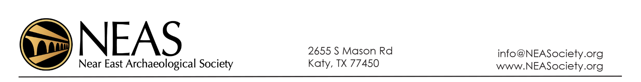
Student Member Scholarship Form

Directions: Complete this form and return before April 1 to Scott Stripling at scott.stripling@thebibleseminary.edu. Awards will be announced around April 15. Scholarships will range from $250–$1000. Recipients will be expected to submit a brief report on their excavation experience or to make a presentation at the next annual meeting.

Name:

Contact information (address, phone, email):

Institutional Affiliation:

NEAS Membership Status:

Proposed Excavation:

Personal Goal for the Excavation: (5–7 sentences)

